Science Fair

Our science fair will be the evening of Thursday March 19. It is not too early to start getting ready for your project. Below you will find resources to help you with your project.

PART 1: Eco friendly display boards
How to reuse the same display board from year to year
- Select a sturdy display board initially. They are slightly more expensive but since you will use the same display board for years you will save money (Lily has used her display board 5 times already) 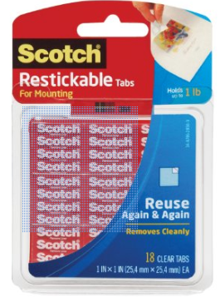
- Use removable and reusable sticky dots from 3M. This allows you to remove the paper without ripping the display board
- Use large paper clamps to clamp the flaps shut so they don’t get torn during transport.
- Store them flat in the back of a closet so they are safe and out of the way until next time you need to use it.

How to make your own display board from recycled cardboard
http://craftingagreenworld.com/2013/10/21/back-school-ideas-project-display-board-upcycled-cardboard/

PART 2: The steps of a science fair project.
Getting started on your science fair project. This webpage has resources to take you through all the steps of your project. The local library also has many books on science fair topics.
http://www.ipl.org/div/projectguide/gettingstarted.html

PART 3: Picking your topic:
You should pick something that really interests you. Sometimes it is helpful to choose a topic that you have already learned something about. In fifth grade you have already studied gravity, the moon, the seasons, the relative brightness of the stars, nutrition, earth systems, the water cycle, weather, human impacts on earth systems, and we have begun studying chemistry.

To make your project even more meaningful you may want to consider participating in a citizen science project. A list of these projects can be found here.

http://hackeducation.com/2011/02/26/5-apps-that-encourage-kids-to-become-citizen-scientists/

http://education.nationalgeographic.com/education/encyclopedia/citizen-science/?ar_a=1

http://en.wikipedia.org/wiki/Citizen_science

Here are some citizen science projects specific to Santa Barbara
http://blogs.discovermagazine.com/citizen-science-salon/2014/09/19/stewards-stream-citizen-science-meets-water-quality/#.VKvyVP2udlI

http://www.graywhalescount.org/GWC/The_Count/The_Count.html

http://www.lapurisimaaudubon.org/PRIDE.html

http://www.inaturalist.org/projects/santa-barbara-museum-of-natural-history-citizen-science-species-inventory

http://santabarbaraaudubon.org/category/advocacy/science/

http://www.news.ucsb.edu/2014/014342/tracking-giant-kelp-space

https://www.naturebridge.org/citizen-science

